Read sections 1.1 - 1.7 of your textbook. The following review questions should help guide your reading. Points possible 30
For each question, you should give a correct answer (as best you know it) or provide an intelligent question regarding the reading that applies to this question and explains why you could not answer the question. (Please note that "I didn't understand any of this" isn't a question, isn't intelligent, and has spelling and grammar errors. It will receive 0 points.)
Make sure to show your work. Answer the questions using your own words and understandings on the chapter materials.
- R1. What is the difference between a host and an end system? List several different types of end systems. Is a Web server an end system? (2 points)
  - There is no difference between a host and an end system. They are terms that can be used interchangeably. End Systems can include, cell phones, tablets, PC’s, and laptops. A web server is also an example of an end system.

- R3. Why are standards important for protocols? (2 points)
  - Protocols are very important to the internet so they need to be agreed on with everyone on what exactly they do. This is so that people can create systems and products that interoperate.
- R4. List six access technologies. Classify each one as home access, enterprise access, or wide-area wireless access. (2 points)
  - Dial-Up – Home access
  - DSL – Home access
  - Cable – Home access
  - Ethernet – Enterprise access
  - WiFi – Enterprise access
  - LTE – Wide-Area Wireless Access
- R8. What are some of the physical media that Ethernet can run over? (2 points)
  - Ethernet can be ran over twister-pair copper wire.
- R11. Suppose there is exactly one packet switch between a sending host and a receiving host. The transmission rates between the sending host and the switch and between the switch and the receiving host are R1 and R2, respectively. Assuming that the switch uses store-and-forward packet switching, what is the total end-to-end delay to send a packet of length L? (Ignore queuing, propagation delay, and processing delay.) (2 points)
  - 4(L/R1+R2)
- R12. What advantage does a circuit-switched network have over a packet-switched network? What advantages does TDM have over FDM in a circuit-switched network? (2 points)
  - The best advantage for a circuit-switched network is that there are reserved communication links between end-systems while packet switches do not. As a consequence, packets may need to wait in a queue.
  - With FDM the frequency spectrum of a link is divided among the connections established across the link. With a TDM link, time is divided into frames of a fixed duration. TDM is able to dedicate a slot for whatever specific connection in this case.
- R28. Suppose Alice and Bob are sending packets to each other over a computer network. Suppose Trudy positions herself in the network so that she can capture all the packets sent by Alice and send whatever she wants to Bob; she can also capture all the packets sent by Bob and send whatever she wants to Alice. List some of the malicious things Trudy can do from this position. (3 points)
  - What Trudy is doing is called packet sniffing. If she is able to intercept packets from Bob she is able to see all the data that is being transmitted unless it is secure. For example, she can get passwords, photos, and any personal messages. Her being able to send packets to Alice is also a huge vulnerability if she can disguise herself as a different sender. For example she could be sending her different viruses to infect her machine.
- P1. Design and describe an application-level protocol to be used between an automatic teller machine and a bank’s centralized computer. Your protocol should allow a user’s card and password to be verified, the account balance (which is maintained at the centralized computer) to be queried, and an account withdrawal to be made (that is, money disbursed to the user). Your protocol entities should be able to handle the all-too-common case in which there is not enough money in the account to cover the withdrawal. Specify your protocol by listing the messages exchanged and the action taken by the automatic teller machine or the bank’s centralized computer on transmission and receipt of messages. Sketch the operation of your protocol for the case of a simple withdrawal with no errors, using a diagram similar to that in Figure 1.2 . Explicitly state the assumptions made by your protocol about the underlying end-to-end transport service. (You can draw a flow chart or a table to explain this scenario). Use the two options below to get stared. (5 points)
- Messages from ATM machine to Server
- Messages from Server to ATM machine (display)
  - The first step in this protocol is to authenticate the correct user to their card and establish a secure connection. The ATM will send the card’s information to the server first. Once the card’s information is received by the server, the server will then reply to the ATM that the card is valid to use. The ATM will then send the password to the server as an acknowledgment that the card is valid and to verify the user. This model mimics the TCP-3 way handshake to establish a connection
  - For all operations after a proper connection is established, the ATM will send a request to the server regarding the selected operation. The server will the verify if the operation is able to be performed or not. If it is not able to be performed, the server will send back a message of denial. If it is able to be performed the server will send confirmation to the ATM to follow on with the operation.

- P7. In this problem, we consider sending real-time voice from Host A to Host B over a packet-switched network (VoIP). Host A converts analog voice to a digital 64 kbps bit stream on the fly. Host A then groups the bits into 56-byte packets. There is one link between Hosts A and B; its transmission rate is 2 Mbps and its propagation delay is 10 msec. As soon as Host A gathers a packet, it sends it to Host B. As soon as Host B receives an entire packet, it converts the packet’s bits to an analog signal. How much time elapses from the time a bit is created (from the original analog signal at Host A) until the bit is decoded (as part of the analog signal at Host B)? Hint: you need to find transmission delay, Propagation delay, and d_{End-t-end delay}. (5 points)
  - Transmission Delay = L/R….64kbps/2mbps = 0.032
  - Propagation delay = distance/speed….
  - d end-to-end = N L/R =
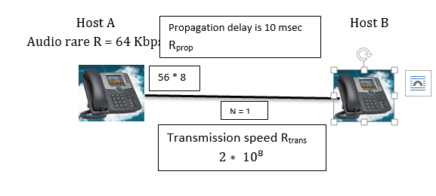

- Consider the figure below, in which a single router is transmitting packets, each of length L bits, over a single link with transmission rate R Mbps to another router at the other end of the link.
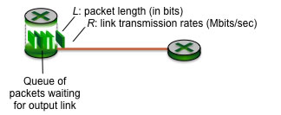
Suppose that the packet length is L= 8000 bits, and that the link transmission rate along the link to router on the right is R = 100 Mbps. (5 points)
(a) What is the transmission delay (the time needed to transmit all of a packet's bits into the link)?
L/R…… 8000bits/100Mbps = 80 Msec
(b) What is the maximum number of packets per second that can be transmitted by the link?
1second/80Microseconds = 12500

